**Global sales Data Analytics**

|  |  |
| --- | --- |
| **Date** | 16-11-2022 |
| **Team id** | PNT2022TMID45267 |
| **Project Name** | GlobalsalesDataAnalytics |

Ideation

Ideation is the process where you generate ideas and solutions through sessions such as Sketching, Prototyping, Brainstorming, Brainwriting, Worst Possible Idea, and a wealth of other ideation techniques. Ideation is also the third 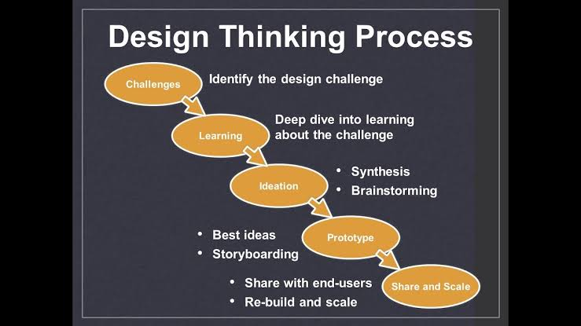stage in the Design Thinking processl

Interested in other ways of ideating Try these

Brainstorm

Brainstorming means to talk openly with the group and work off the synergy that has been created. The brainstorming technique works by taking each other’s ideas and building off of them to create a final idea. This works well in an environment with trust where participants feel they can speak freely without being judgede

Braindump

This is very similar to brainstorming – but rather than talking freely with the team the braindump is done by participants writing on post-it notes individually and then sharing with the team.

Brainwrite

Brainwriting overlaps with brain dumping but participants here should write down their ideas on paper for a set amount of time (we suggest 3 minutes) and then pass their sheet one space to the left to their team member. This team member then elaborates on the other participants’ ideas. After a few minutes more the participants pass their papers around again and this continues until a full circle has been made.

Brainwalk

Brainwalking utilises movement to spark creativity. Rather than passing a paper around a circle – participants walk around the room to different ideation stations where they then elaborate on other participants’ ideas.

Analogies

Analogies can be a wonderful ideation technique as they bring a better understanding forward through drawing parallels. By comparing what you are trying to solve for with different objects and scenarios – you can generate out-of-the-box ideas based on understanding the topic in different ways. For example drawing a comparison between a heart and a pump.

Creative Pause

This one is great if you feel that you have built up a negative thought process around the product or service or feel stuck in a one-track thought. Pausing mindfully and taking a break from the traps you might have laid out for yourself can do wonders for sparking better ideas.

